IT24102795

Lab 3

1.

2.

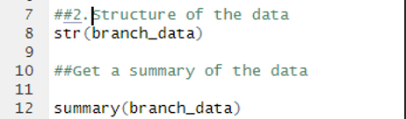

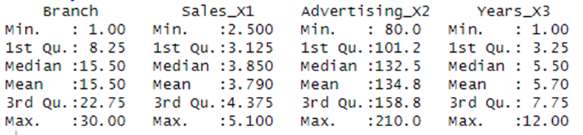

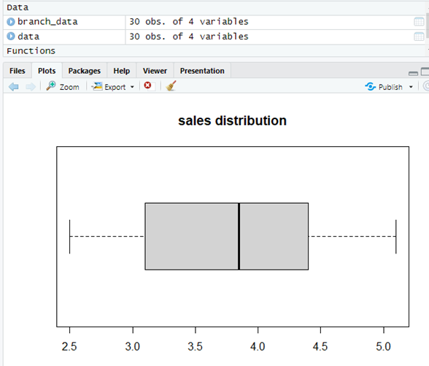

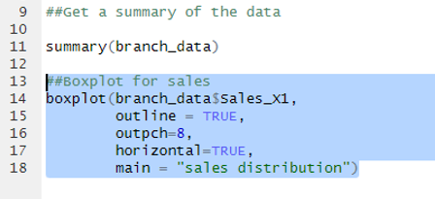

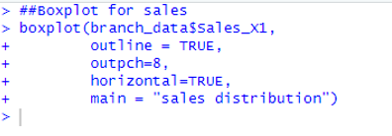

4.

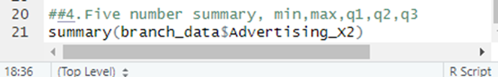

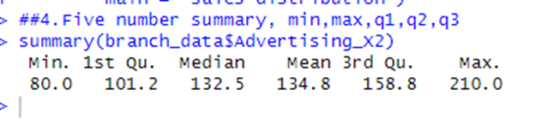

Calculate the IQR

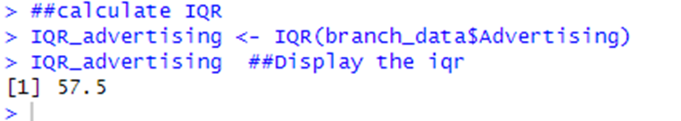

5.

